Mulberry Lodge Spicy Plum Jan

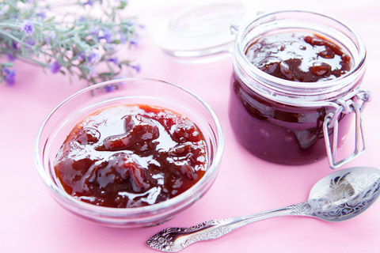

Makes 7 Cups

Ingredients

1 tsp black peppercorns
1 tsp star anise seeds
6 cloves
1 cinnamon stick
2 dried bay leaves crumbled
2 cups dry red wine
1.25Kg of whole sugar
2kg plums quartered and stoned
1/3 cup (80ml) of lemon juice

Method
- Place a couple of small saucers in the freezer to chill. Place spices, bay leaves wine and 1 cup of sugar in a large wide heavy based saucepan and stir over medium heat until sugar dissolves. Bring to the boil then simmer for 10 minutes. Turn off heat and leave to cool. When cool strain through a fine sieve over a bowl
- Return strained syrup to pan with 1 cup water and plums. Bring to the boil. Cover with a lid and simmer over low-medium heat for 35 minutes.
- Uncover pan. Add lemon juice and remaining sugar. Cook stirring until sugar dissolves. Bring to the boil then simmer, uncovered, over medium heat, skimming from the top for 45-50minutes or until jam jells when tested.
- To test place a small spoonful; on a chilled saucer then return to freezer for 1 minutes. Run your finger through the chilled jam; it should be the consistency of honey and wrinkle slightly when pushed.
- Once at this stage pour into hot sterilized jars and seal

www.mulberrylodgewillunga.com

