Oat & Raisin Cookies
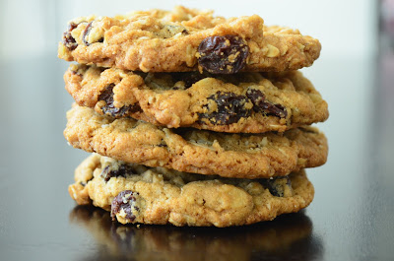

Preheat the oven to 160 degrees. Line baking sheets with baking paper.

1 cup + 1 teaspoon all-purpose flour
1 tablespoon ground cinnamon
1 1/2 teaspoons baking soda
1 1/4 teaspoons kosher salt
1/2 cup + 3 1/2 tablespoons lightly packed light brown sugar
1/4 cup + 1 1/2 tablespoons granulated sugar
11 tablespoons butter, room temperature
1 egg
1 1/4 teaspoons vanilla paste (I used vanilla extract)
2 cups old-fashioned oats (do not use instant)
1 cup raisins

In a medium bowl, whisk together the flour, cinnamon, baking soda and salt. In a separate small bowl, whisk together the sugars until no lumps remain.
In the bowl of a stand mixer, cream the butter on medium speed. Add the sugars and mix for 3-4 minutes until mixture is light and fluffy. Scrape down the sides and bottom of the bowl. Add the egg and vanilla and mix on low until just combined (do not over mix). Again, scrape down the bowl again. Add the dry ingredients in two additions while mixing on low speed. Mix until just combined. Add the oats and let the stand mixer go around for about 10 revolutions to combine. Then add the raisins until they are just incorporated do not over mix.
Refrigerate the dough for 30 minutes.
To make 6 large cookies, use an ice cream scoop and divide the dough into 6 equal portions. Roll them into balls and place 3 on a cookie sheet. To make smaller cookies, portion the dough into desired amount of equal pieces and roll them out.
Bake at 160 degrees for 21-23 minutes if you made 6 cookies. If you made 12 cookies, bake at 160 degrees for 18-20 minutes, adjust time accordingly.
Set the pans on a cooling rack for 5-10 minutes and then transfer the cookies to the rack to cool completely.
Yield: 6 large cookies or 12 regular.

ENJOY

